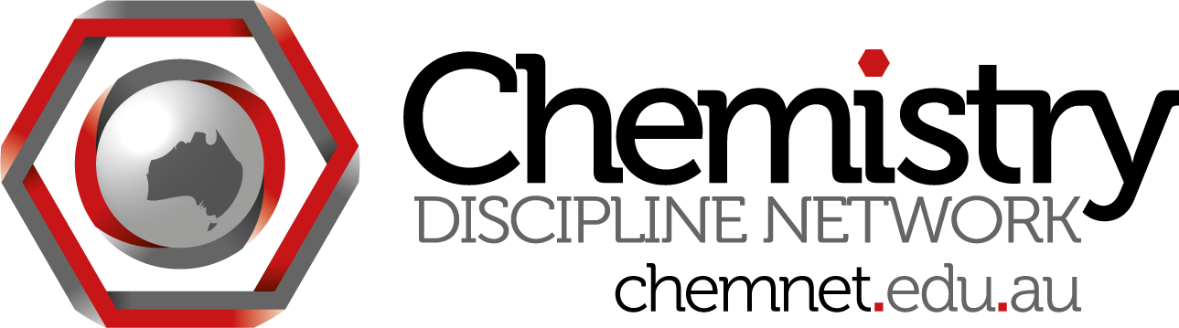
ChemNet skype meeting #13
Wednesday January 30 at 3:30 pm Brisbane time
Attendees:
Madeleine Schultz (QUT) madeleine.schultz
Glennys O’Brien (Woollongong) glennys.obrien
Kieran Lim (Deakin)
Siegbert Schmid (USyd)
Steph Beames (UTS)
Dino Spagnoli (UWA)
Will Rifkin (UQ)
Roy Tasker (UWS)
Lachlan Yee
Magdalena Wajrak (ECU)
Roger Read (UNSW)
Gwen Lawrie (UQ)

Minutes:
- Feb 4 TLO to standards meeting 2013.
Meeting for Feb 4 details - on Monday. 23 people coming. Trying to get the points from December meeting all together. Will look at students meeting TLOs and turning these into benchmark statements. May have input from outside Australia for benchmarks.

Homework: on chemnet website under ChemNet documents. Report from Dec 12 meeting.

Things to keep in mind:
slightly different degrees eg bachelor of med chem, biochem. Degrees that might have a bit less chemistry - do they define a chemist?
Spectrum of activities in different institutions
Roy - there may not be a clear cut difference between a chemistry degree, biochem degree, etc.
Roger - core elements satisfy chemistry. Science is difference from accounting, and chemistry is different from other sciences.
Roy - hard to write TLOs to exclude other areas..

2. General discussion
Roger Read - ex-RACI board, on reference group for TLOs, organic chemist, interested in accreditation.
Magdalena - ECU has lost chemistry degree, question whether RACI would accredit their major. Looking at just hours in lab is not sufficient.
Glennys - may be there will be separate processes, one for TLOs (science) and one for chemistry accreditation (RACI)
Roger - need to see what defines a chemist as distinct from mathematician, engineer etc.

3. Conferences - Pacifichem
Siggi: I have got in contact with Tom Holme about his suggested symposium re assessment. I will be in NZ next week to discuss their interest in sponsoring this symposium as well.
Kieran: usually for Pacifichem good to have one non-english speaking county in each proposed symposium. Interested in being involved but may not have enough on assessment. Last Pacifichem was involved in a symposium on professional ethics in chemistry. US, Canada, Aust group. Backed by ACS professional ethics committee. Generic skills would be interesting for this time, or maybe something like ASELL - India and the Philippines have shown interest in ASELL, and there is an NSF grant for chemistry ACELL in the US. Not with lab sessions, oral session discussing labs and hands on learning.
Roger: ACELL would be great if there are shared experiments and people share data around the world. Could be expanded. Experiment-based and theory application theme.
Kieran: also relates to assessing lab learning.
Glennys: we assess work in lab by watching students
Gwen: using wikis to move away from lab reports
Magda: lab skills test for titration in first year, they get to practice first
Roy: question is, are we using the lab time in the best way possible. Assessing skills appropriate at third year, they should have manipulative skills
Gwen: problem is with large numbers, if tutors doing the assessment, hard to be fair
Roger: group activities and assessment are also interesting - many different models, worth sharing info.
Magda: share info on what works and doesn't with group assessment.
Streams within a major assessment symposium: lab, group work, nontraditional, MC exams...
Ties in to TLOs, academics can look for different ways to assess their TLOs from different strands
Kieran: can even seek sponsorship to pay attendance of big names in symposium, need to invite all speakers, try to attract speakers and audience.
Should aim for around 2 days. One session on each theme.

Same model for new RACI congresses - symposia already chosen, on RACI website.

Siggi: ICCE 2016 in Sydney - first quotes. will send email

Next meeting: Wednesday 27 Feb 4:30 eastern summer time, 3:30 pm Brisbane time.

