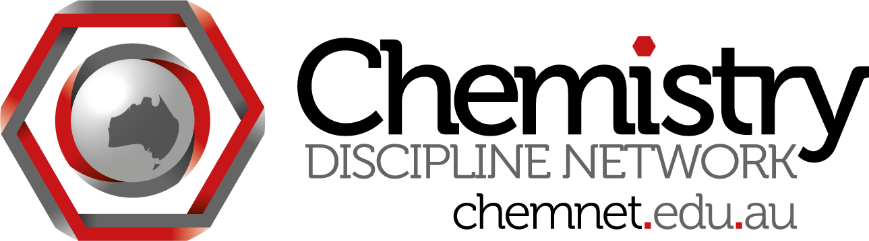
ChemNet skype meeting #8
Wednesday July 25 at 3:30 pm Brisbane time
Attendees:
James Mitchell Crow (Project officer) jmitchellcrow
Madeleine Schultz (QUT) madeleine.schultz
Chris Thompson (Monash) christovac
Steph Beames (UTS) stephaniebeames
Siggi Schmid (USyd)
Will Rifkin (USyd) will_rifkin

Minutes:
- ACSME meeting - Assessment of TLOs
Agenda now on website
Chris - the other kind of TLOs like inquiry learning, nature of science - need to ask the hard questions
People to bring some assessment items, can choose a TLO
Steph - will help out at the meeting

2. Shared exam questions
Steph - session on MC questions as ideas exchange - how to write effective ones. People could bring hard copies.
Will - or share one question

3. T&L Centre for ACDS
Will - Liz Johnson would like input from Discipline Networks - leaders will chat at ACSME. What would be useful from the centre? We need to poll our members so can provide input.
Also to discuss operational insights - share thoughts on how it has worked or not.

4. Other business
Chris - chem misconceptions

Next meeting: Wednesday after ACSME

