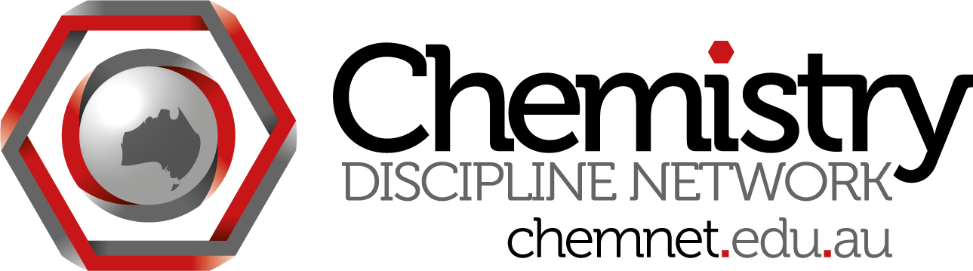
ChemNet skype meeting #15
Wednesday March 27 at 3:30 pm Brisbane time
Attendees:
Madeleine Schultz (QUT) madeleine.schultz
Gwen Lawrie (UQ)
Steph Beames (UTS)
Siggi Schmid (Syd)
Roger Read (UNSW)
Feng Wang (Swinburne)
Lachlan Yee (SCU)

Minutes:
- ACSME meeting in Sept title for Chemistry Network Meeting 1 - 3:30 pm Sept 19 UCan.
Maybe half an hour on summarising the end of chemnet, what happens next. Will we continue skype meetings? newsletters? The rest of the time on TLO to assessment work.
Possible titles:
The Future of ChemNet and Assessing TLOs
Where next for ChemNet?
Idea: Will ACDS centre help us to keep existing in some form? There should be info on ACDS Centre at ACSME meeting
Problem: it is a teaching week for USyd, UNSW, UQ etc.
Evening meeting? Thurs evening? To allow Sydney people who have teaching to come.

2. General discussion
Future of education video - Lachlan's youtube. Tailored education - custom education.
Personalised learning environments.
Staff of politician in Wollongong says the future is all lectures online. Money saving!!

3. TLOs and Bachelor of Science
Germany - Bologna hasn't changed that the chemistry degree is just chemistry. Get the generic TLOs at a very high level through research papers. Very different to Australian students.
BSc - bachelor of science - general degree. TLOs at lower level (first year)
Different context and approach and they are there for a long time, knowing where they are going.

4. Catalyst grant
How should we choose who to fund? Need to make a deadline and then review applications.
Funding range? around $500 - $1000, possibly more for joint application
Next meeting: Wednesday 24 April 3:00 eastern time

